**InSOgram**

**InSOgram** is a company that focuses on **photo** and **video sharing** social networking service, that allows users to **like photos or post, follow other users**, etc. The project manager, **Andrew** wants you to create a website for **InSOgram**, which support **non-Latin characters** in all pages such as Mandarin, Japanese, Russian, etc.

In website development, **Andrew** hopes that you understand **what technology you are using** and **why you are using it.** To monitor your work progress, **Andrew** as project manager wants you to use **Git** version control system, you must use **GitHub** your repository manager. Make sure that your repository for this project is set to **private** and invite **Andrew** as **collaborator** so that nobody except you and **Andrew** could manage or monitor your work. **Andrew** hope that you can uphold **integrity** so make sure every time you are about to present your work to **Andrew**, you are presenting what you had done until **last commit before the deadline.**

In this project, you are asked to use **GoLang** as the backend language that will be used for creating **GraphQL API**, followed by **React.js** to build interactive elements on websites (frontend). To make sure you are using **GraphQL API** in the right way, your backend must be accessible by only **1 endpoint**. For the database, you are asked to use **PostgreSQL**. You are free to **create and design the database**, but you must have **strong** **logical** and **reason** **why**.

There’re some factors that you should notice when develop this project such as **performance**, **design**, **security** and **tools understanding**.

In the performance factor, you are asked to use **Redis** to **cache** the result of any API data you consume. You are asked to use **RxJS** javascript library to help you deals with asynchronous programming problems.

In the design factor, you are asked to generate **color pallete** that includes **primary** , **secondary** , **accent color** of your project, following **60/30/10 rule**. The web design must be **responsive** with **at least 3** **breakpoints**, **mobile**, **tablet** and **desktop**. Beyond responsive design, you are asked to make your application support **progressive web applications** to deliver amazing user experiences. Because **Andrew** wants the website to be super **interactive** and **amazing**, you are asked to add **several** **animation** to this website.

Since Andrew notice that so many junior programmers that don’t have **strong** **foundation** in CSS, Andrew hopes your CSS skill will **increase significantly** after you **finish** this project. With intention to **improve** your **CSS skill**, you are **prohibited** to use any **CSS library or UI Component Library** such as Bootstrap , Tailwind CSS, Material UI , Prime , etc for this project. Andrew want to share the wonderful feeling of **SASS/SCSS** styling language, so you are asked to use it.

Other than **UI** and **Design**, please consider the **UX** of the application, to provide **positive experiences** that will keep users loyal to our website, you must know **how the user interact** and **how to give the best experience to users** when visiting our website.

In security factor, you are asked to use **OAuth2** for login authentication process.You may use any authorization server as long as it free, it suggested to use **google authentication** server. If you found any bugs in any technology you are using, report bugs to the official website and write your documentation what bugs you had found.

In tools understanding factor, you are asked to just simply not just use the tools, but **understand** *what*, *why*, *how* and anything that *related* to the tools you are using. For example: Do the tools implement any design pattern or infrastructure patternthat you maybe could add to your project.

While working on this project, remember what’s the main functionality of the web, focus on **learning something new**, find some motivation when you’re unmotivated, rest when you are tired, work smartly, be creative, and have fun.

Project Requirements

1. **Header**



Figure 1. Guest Header

* *Guest Page:*
* Display website **logo**
* Display **Search bar** to search for **users**, and **hashtag** , also display **auto-complete** and **search history** when user type in the **search bar**
* Display **login** button and redirect users to **Login Page** when clicked
* Display **Sign Up** button and redirect users to **Sign Up Page** when clicked



Figure 2. User Header

* *User Page:*
* Display website **logo**
* Display **Search bar** to search for **users**, and **hashtag** , also display **auto-complete** and **search history** when user type in the **search bar**
* Display **navigation bar menus** available to navigate to other page
* Display **indicator , badge, or mark** so user know there is unread notification
* Differentiate **current active page** with **inactive page**
* Display **User’s picture** as account button, when clicked display functionality and settings as below :
  + Show **profile** menu, which redirect to **User Page** when clicked
  + Show **Saved** menu, which redirect to **User’s Saved Post** when clicked
  + Show **Settings** menu, which redirect to **Edit User Page** when clicked
  + Show **Logout** menu, which **Logout** current user and redirect to **Login Page**

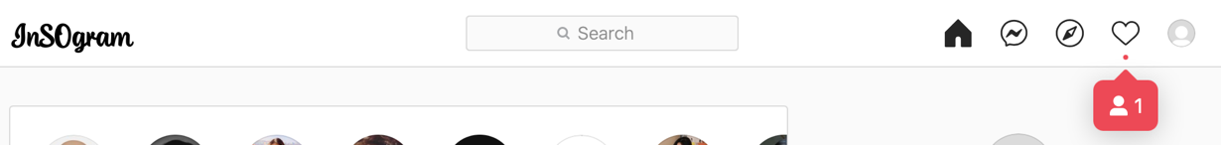

Figure 3. Badged Notification

1. **Footer**
   * Provide at least **10 useful site links** to access site pages ( ex : about, blog, help, etc.)
2. **Login Page**



Figure 4. Login Page

* Validate **Logged in user** **can’t access** this page
* Validate **email** and **password** must be **filled** if **not,** show **error message**
* Validate **email must be a verified email** , otherwise show error message
* If credentials are **valid** then redirect to **Home Page**
* Login with **social media min. 1** ( ex: facebook, twitter, google, etc )
* If **user (guest)** don’t have an account, then user can click **sign up button** then redirect to **Sign Up Page**
* If **user (guest)** lost or forgot his/her credentials, then user can click **forgot password button** then redirect to **Forgot Password Page**

1. **Sign Up Page**



Figure 5. Sign Up Page

* Validate that **Logged in user** **can’t access** this page
* Validate that **all field must be filled,** if **not,** show **error message**
* Validate that **email must be verified** by **sending email** to user’s email
* Validate that **email** and **username** must be **unique** if **not**, **show error message**
* If **user (guest)** already have an account, then user can click on **login button** then redirect to **Login Page**
* Show **resend verification email button**, and **set countdown** to resend email to **corresponding user’s email**

1. **Forgot Password Page**



Figure 6. Forgot Password Page

* + Validate **Logged In user** **can’t access** this page
  + Validate **all field must be filled,** if **not**, **show error message**
  + Validate **email** must be a **registered user email**
  + Send **email to reset account password**
  + Set **countdown** to send **another email**

1. **Home Page (User only)**

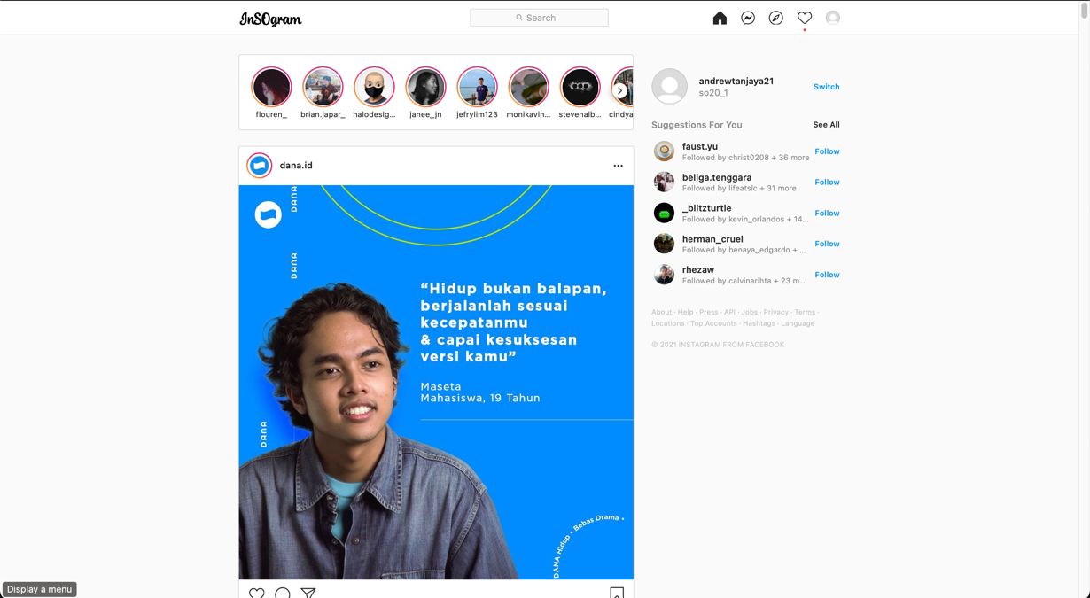

Figure 7. Badged Notification

* + Validate user must **be logged in** first before accessing this page, if not **redirect** user to **Login Page**
  + For each **Story** :
    - Group stories by their uploader
    - Only show stories of the user you are **following**
    - **Mark** stories that have been viewed by the user
    - **Separate** the stories that the user has seen and those which the user hasn’t
    - Display the **uploader’s profile picture** as the **story button** which will redirect to the **corresponding story**
    - If the uploader has multiple stories, start viewing from the one that the user hasn’t seen yet.
  + For each **Post** :
    - Show only the post followed user.
    - Show **video(s)** or **image(s)** present, if there are more than 1 images or videos, use a **slider** to view them. Make sure that the user could freely navigate between photos or videos.
    - Show post **owner username** and **profile picture**
    - Redirect to **User Page** when **post owner’s username** is clicked
    - Show the post **owner’s profile picture**, which will serve as the **story button** if that user has uploaded a story. Show similar **indicator** as stated in the previous part to show if that user has a **story** that is **yet to be seen.**
    - Show post’s **tagged user**, and redirect to the corresponding **User Page** when a tag is clicked
    - Only show a **shorter version** of the **post’s caption**. Provide a **button** to **toggle** the caption view, either to view the **shorter** or the **full** version of the **caption**.
    - Show **post’s hashtag** (if any) and show **posts** with the **same hashtag** when hashtag clicked
    - Show **posted time** ( ex: 2 hours ago, 3 minutes ago , etc)
    - Display **Save Post button**, when clicked toggle **save** and **unsave** post, **Add post** to **User’s Saved post** when **Save button clicked**, then **Delete post** from **User’s saved post** when **Unsave button clicked**
    - Display **Share button**, which will show modal to share **post URL by copy to clipboard**, another **social media**, or **DM**
    - Show **Like** or **Dislike** button, when clicked **toggle** between **like** or **dislike** post
    - Show post’s **Like Count**
    - Show post’s **Comment Count**
    - Display the counts using a metric system ( 4.1K, 4M , etc ) so that the user won’t be overwhelmed by a large number of digits
    - Display **Post’s Comment** with fuctionality and requirement as following:
      * Logged In User can **Add comment**
      * **Delete** user’s comment / comment from user’s post
      * **Mention** / **tag** other user in comment
      * Show **Like** or **Dislike** button, when clicked **toggle** between **like** or **dislike** comment
      * Initially show **max 5 recent comments**
      * if there are **more than 5 comments**, then show **another 5** when user click **show more comments button**
    - Every comment can be **replied** with functionality and requirement as following :
      * Display **hide** and **show reply button**, when clicked **toggle** hide or show reply
      * Show **Like** or **Dislike** button, when clicked **toggle** between **like** or **dislike** reply
      * **Add** comment reply
      * **Delete** own reply / reply from own post
      * **Mention / tag** other user in reply
      * Initially hide all replies
      * show **view replies button** and **replies count**, which will show replies of **corresponding comment**
      * Show **max 3 replies** at first, if there are **more than 3 replies**, then show **another 3** when user click **show more replies button**
    - If post is **logged in user’s post**, than :
      * User can **delete** post and show **confirmation pop up** before post deleted
      * User can **edit** post’s caption
  + Considering **the web performance**, implement **infinite scroll** when displaying **posts**
  + Show **Logged In** **User** information such as username , profile picture, name etc.
  + Show **Logout** button , when clicked **logout current logged in user** and redirect to **Login Page**
  + Show maximal **10 mutual user** and **show more button**, when clicked redirect to **Suggestion Page**

1. **Story Page (user only)**

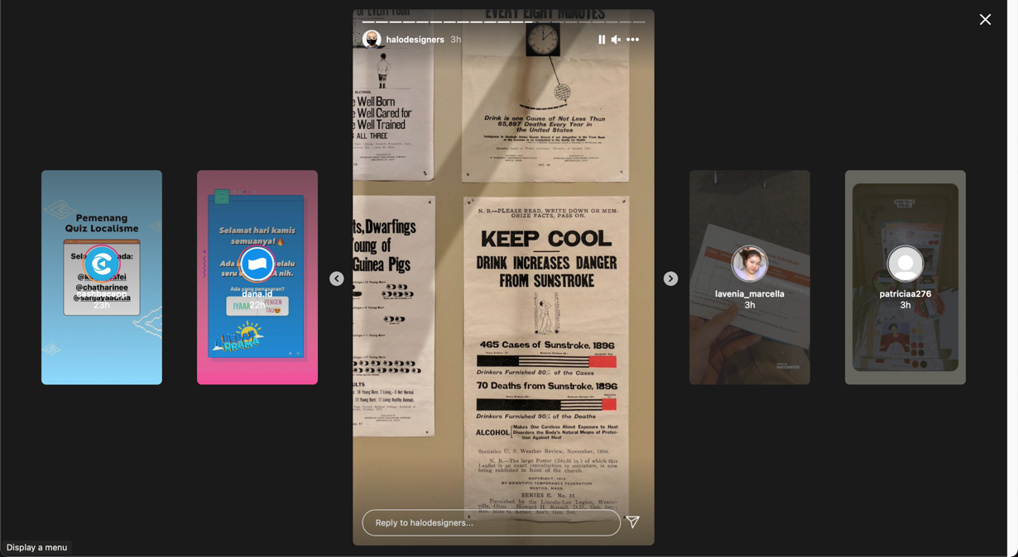

Figure 8. Story Page

* + Validate user must **be logged in** first before accessing this page, if not **redirect** user to **Login Page**
  + Show **Choosen** Story from **Story List (Home Page)**
  + User can **Add Story** with functionality and requirement as following :
    - User can make story of **video, image , post, or mentioned story**
    - User can **Tag** or **Mention other user** in the story, and **send story** to **tagged** or **mentioned user** through **DM**
  + **Manage** Close Friend list
  + If Story contain **post**, then redirect to **the post** when post clicked
  + If the story **mentioned** a user, then **display popup** that show corresponding **username** and **profile picture** which will redirect to the corresponding **user page** when clicked
  + If Story contain **other user story**, then redirect to the **user page** when story clicked
  + **Post** story to **close friend list** , or all **followers**
  + **Delete** own story
  + **Play** / **Pause** Story, on **mouse down** or **mouse up** in the story
  + **Show Next** / **Prev** Story button, when clicked proceed to the **next or previous story**
  + Validate that **each story** will be **expired** in **24 hour** since the story posted
  + Display **Share story button** , when clicked share story to **DM** and **Validate** share only to **user followed by Story owner**
  + Display **Story progress bar** corresponding to **real video / image duration**
  + Display **Story progress bar** **count** corresponding to **user story count**

1. **Direct Message (DM)**



Figure 9. Direct Message

* + Support **Realtime** Chat, always wait and sync whenever new message is received
  + Show **Chat history** list
  + Show if other user is **typing**, so that the receiver knows that sender is going to reply the message soon
  + Show **realtime chat notification** whenever new chat is received or new request is received
  + Show **last message sent** or **received** in **chat history list**
  + Differentiate chatbox that has received new messages
  + **Sort** the chat list so that the **newest** **chat** will always be on **top**.
  + Able to **send photo** in the chat
  + Able to start **video call** in the chat
  + Able to receive **shared post**
  + Able to receive **mentioned story**
  + Able to **repost mentioned story**
  + Start **new chat** :
    - You will be able to chat **public** account or **followed** account only
    - Enable a **search** user feature to start chatting
    - Show list of **following user**
    - If you **haven’t followed** the user you are trying to **chat** yet, send a **request** instead which the end user could **accept**, **reject** or **block** you.
  + You could delete you **message** in a chat room
  + You could also delete a whole **chat room**

1. **Explore Page**

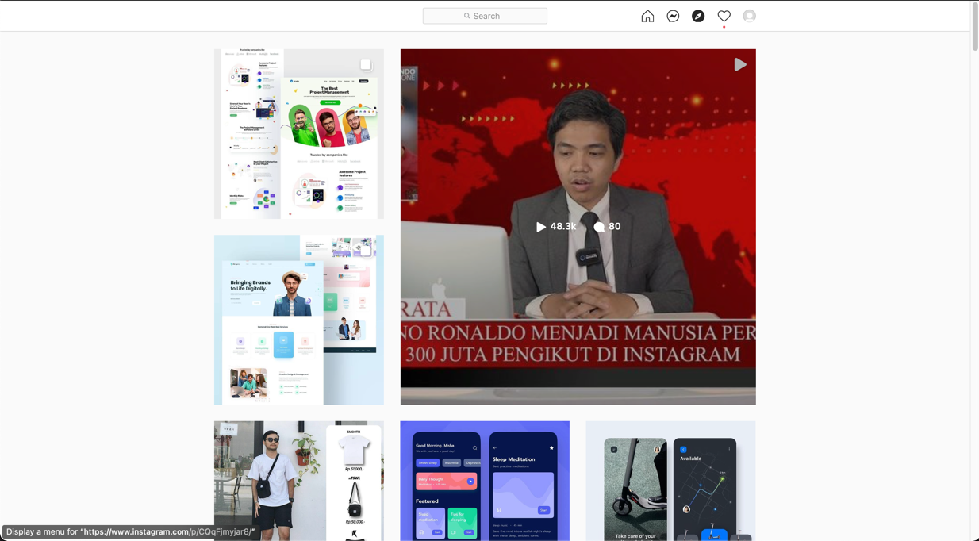

Figure 10. Explore Page

* Show all popular ( most views and like ) posts within the range of 1 week before today. Ex : if today is July 5th, last week will be June 29th. Show posts within the range of Jun 29th to July 5th
* Considering **the web performance**, implement **infinite scrolling** when displaying posts

1. **Activity**



Figure 11. Activity

* Show current **notification** (follow, tagged post, mentioned story, like, comment, etc)
* Show **notification detail**
* **Redirect** user according to the **clicked notification**, if it’s about a post then redirect to the corresponding post, if it’s about a user then redirect to the corresponding user’s profile page, etc.
* Show **realtime notification,** whenever a new notification is received.
* Display **Show all button,** when clicked redirect to **Notification Page** which wil **show all** notifications

1. **User Page**

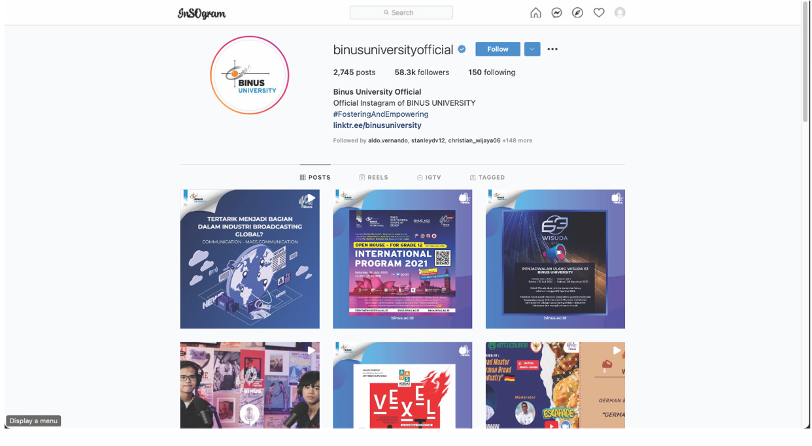

Figure 12. User Page

* Show **user profile information** ( username, bio, name , profile picture)
* Show **user’s posts** and **tagged posts**
* Show **user post count** ( ex : 2K, 2M , etc )
* Show **followers** and **following** count ( ex : 2K, 2M , etc)
* If **logged in user** **page**, then :
  + Show **saved posts**
  + **Edit profile** button(username, gender, email, picture, private/public, password)
  + **Add Post** button,which will be redirect to **Add Post Page** when clicked
* If user have an active story, then make the user profile picture as a button to redirect to **Story Page** and show the **story of corresponding user**
* **Toggle Follow / Unfollow** user, if user is **private** then send **follow request**
* Prove a message to **Direct Message** the user, **redirect** to **DM page** and automatically **create a room** for them

1. **Add Post Page**
   * Available in **two way file input** (input tag and drag and drop functionality)
   * Show **Photo(s)** or **Video(s) inputed** preview
   * Option to **share post automatically** to other social media such as facebook, twitter , etc
   * Show **autocomplete** when trying to **tag** other user
   * Tag **can be moved** and **positioned anywhere** on the top of the photo or video
   * **Every photo or video will be able to have different tags**, so user can choose which photo or video to tag
   * Show **upload progress bar** and show **popup** when upload is completed
   * Validate **post can’t be uploaded yet** when progress bar was not completed
   * **Validate** that the caption must not be empty
   * Show **error message**
2. **Others**
   * Enable the user to toggle between **dark mode** and **light mode**.
   * **Every video or story player must be custom**, default player are prohibited
   * Everytime the user **hovered** a user profile for a while, show the corresponding **user** **profile preview,** enable user to easily see brief information , **message** or **follow** corresponding user

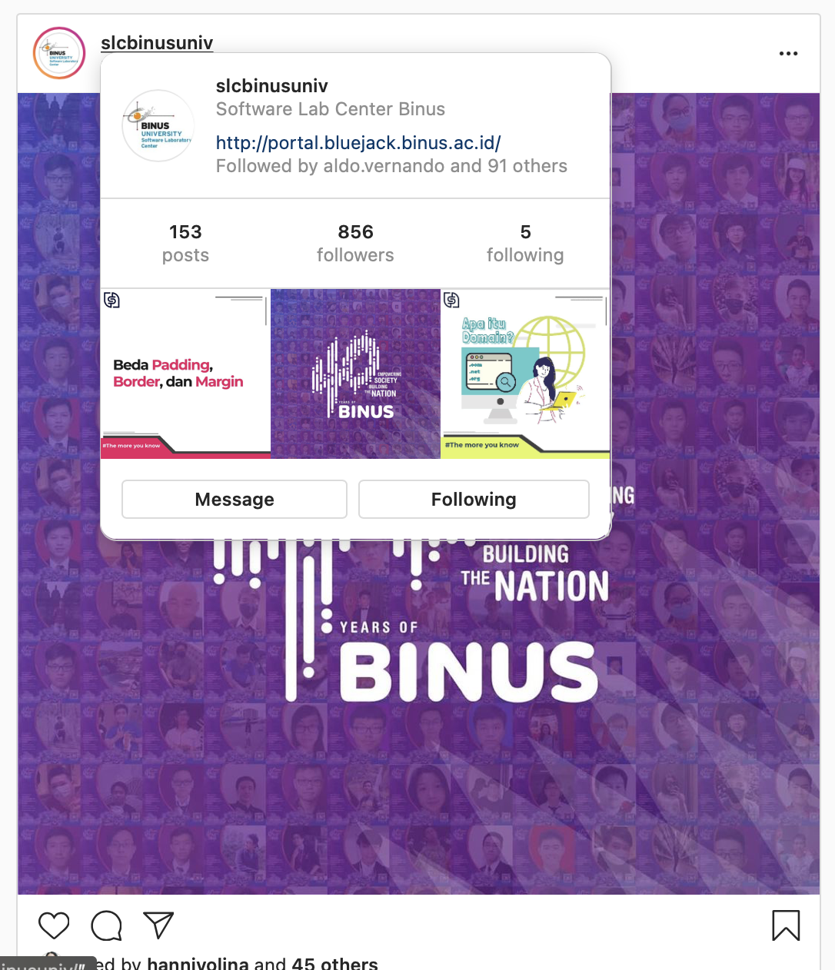

Figure 13. Profile Preview